BC Hydro Survey Helper

Initial Software Proposal

Prepared by Alex Wiecke

For Dr. Jahangir Hossain, Ph.D.

# Introduction

This document is a discussion of the structure and design of the as-of-yet-unnamed application to be developed for Amec Foster Wheeler plc (Amec from here on) to assist in the process of surveying BC Hydro power transmission poles. The goal of this discussion is to relate an early concept for the overall structure of the application, as well as to reveal some of the underlying framework needed to support it.

# Application Structure

As a guide for initial design steps an overall structure for the application must be developed. To this end, based on the meeting held July 8th, several key features within the UI and the overall workflow have been identified. This section describes these features.

## Workflow Overview

The application can be considered as two flows. The UI Flow experienced by the user, and the flow of data handled behind the scenes. In the diagram below, each block shows a piece of the app that must be developed. This preliminary layout shows how the user will login, view a list of assigned poles to survey, then complete a the set of tasks associated with that assignment. Once the survey is complete it can b reviewed before either placing in a local data repository or, if network access is available, sending it directly to remote storage and processing. Each of the elements of this workflow are described in brief in the next section.

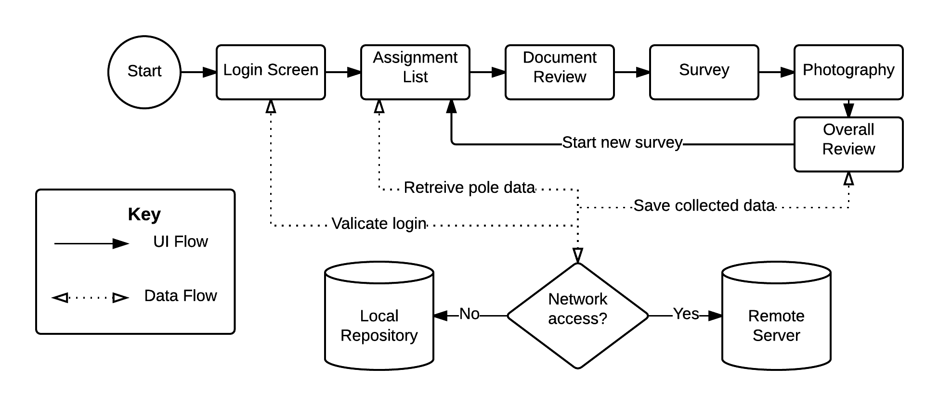

Figure - Overview of the workflow of the application

## Workflow Components

### Login Screen

The user must authenticate before starting a survey. This is to ensure that each survey can be positively linked with a particular user for traceability as well as data security.

### Assignment List

AMEC/BC Hydro must supply information for each power pole assigned to a particular surveyor. This menu will list each assigned pole along with basic information such as its location, or possibly a map preview, in order to enable the user to select the next pole to survey. Once the selection has been made the user proceeds to the next step and begins surveying that pole.

### Document Review

Poles may have a set of documents associated with them, including maps, safety, environmental and legal information. This page provides the ability to select and view these documents one by one, and requests confirmation from the user that all documents have been reviewed before proceeding. These documents are provided by AMEC as part of the aforementioned pole assignments.

### Survey

Once documents have been reviewed, the user must fill out a survey regarding the pole in question. These questions will be based upon the sample paper form originally provided by AMEC. Along with each yes/no question, the option to add a comment will be included.

### Photography

As part of the surveying process, the user must take several photographs of the pole. Initially the onboard camera and in-built APIs will be used to take the photos, but if requested after later stages of development an external camera may be integrated if it is found to be feasible. The user may be prompted in this section to take certain kinds of photos (i.e. angles, framing) before moving on.

### Overall Review

Now that the survey is complete, the user may view an overall summary of the survey, and go back to earlier steps in the survey to alter them if need be. Once confirmation that the information is correct and complete is given, the collected data can be prepared for the database.

### Data Upload

Data collected by the user is either stored in a local repository using the device’s filesystem, or if network access is available sent immediately to remote servers for storage and processing. Data may be checksummed and/or encrypted locally to ensure its integrity and security.